SERVICE NOW:

We have to use the below link https://carnival–service-now.com contains ticket history which are solved and all the history associated with the ticket. We can use our carnival credentials to login into this website. We can search for specific keyword on the top and hit the enter to view all the details associate with that keyword.

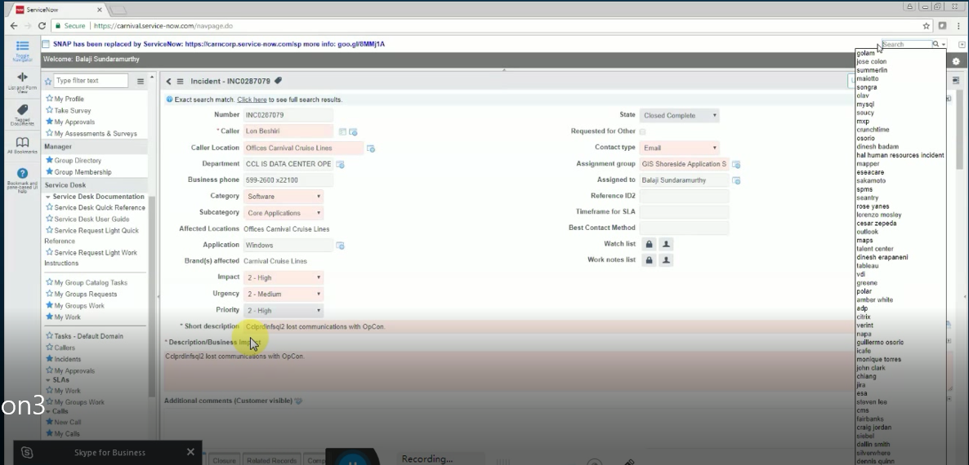

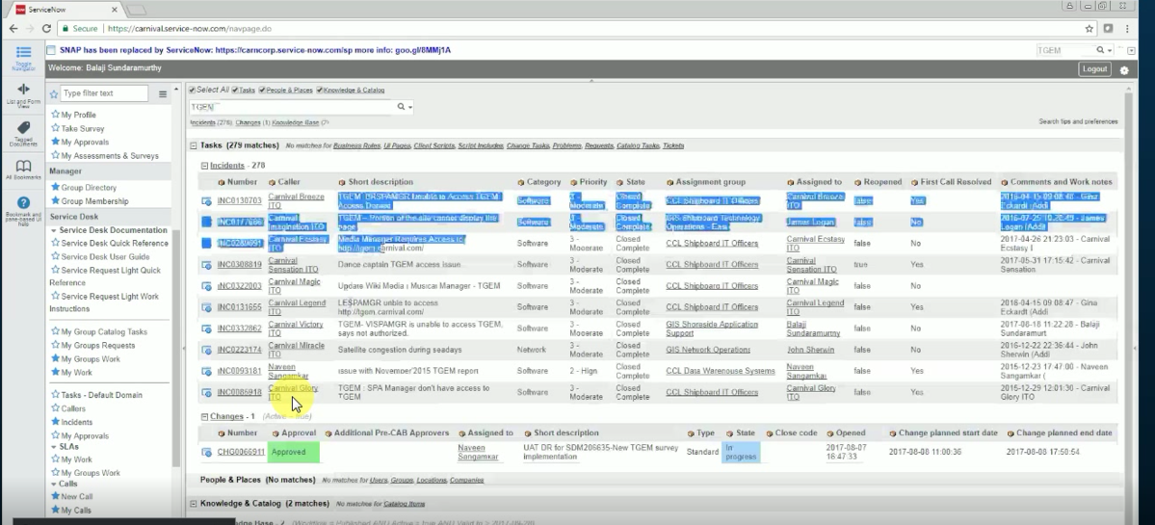

This is the new service now where we will get the tickets are various details :

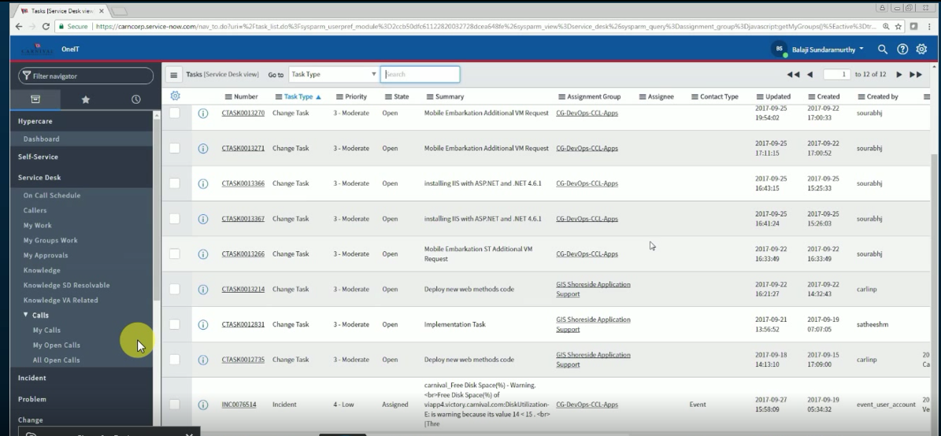

Go to the dashboards and click on my groups we will get all the previous and new tickets associated with our group and My work will show all the details associated to you.

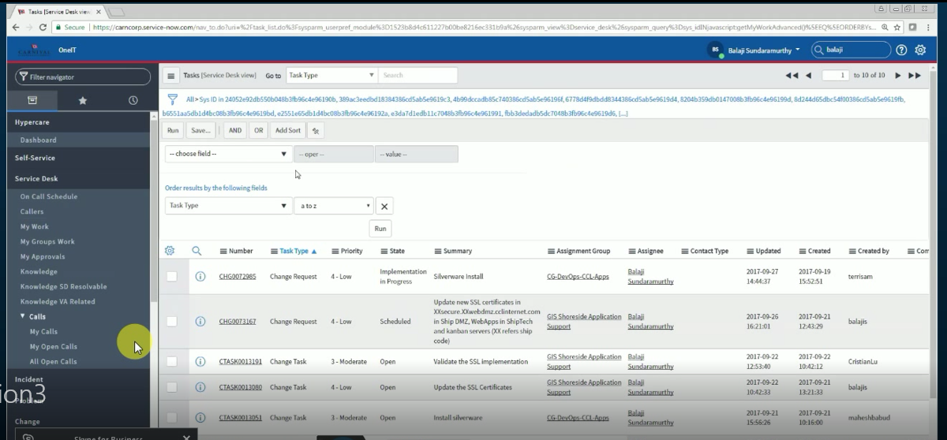

Basically we are deal with tickets from three groups

1. CG-DevOps-CCL-APPS: CG-DevOps-CCL-APPS: This is the new group created for GIS SHORE SIDE Application support.
2. GIS Shore Side Application Support : This is the old group where the tickets where assigned
3. CCL IS RECORD Management Support: The scenario where user will call to the help desk for some issue and when the help desk is also not able to solve the problem then the ticket is assigned in this group mainly they are server related issues.

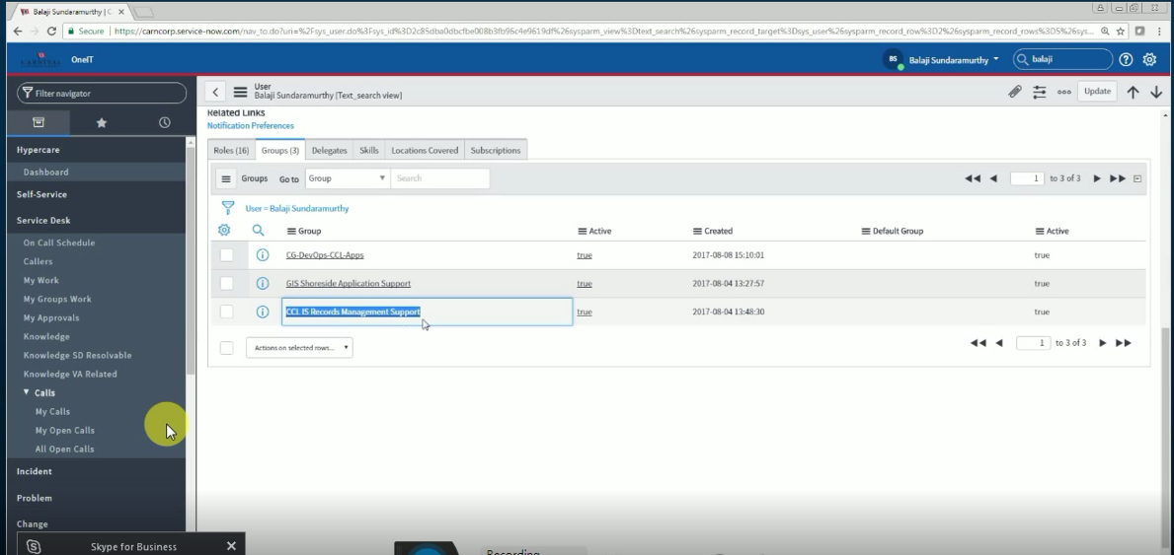

Go to Dashboard go to my profile to change your communication information.

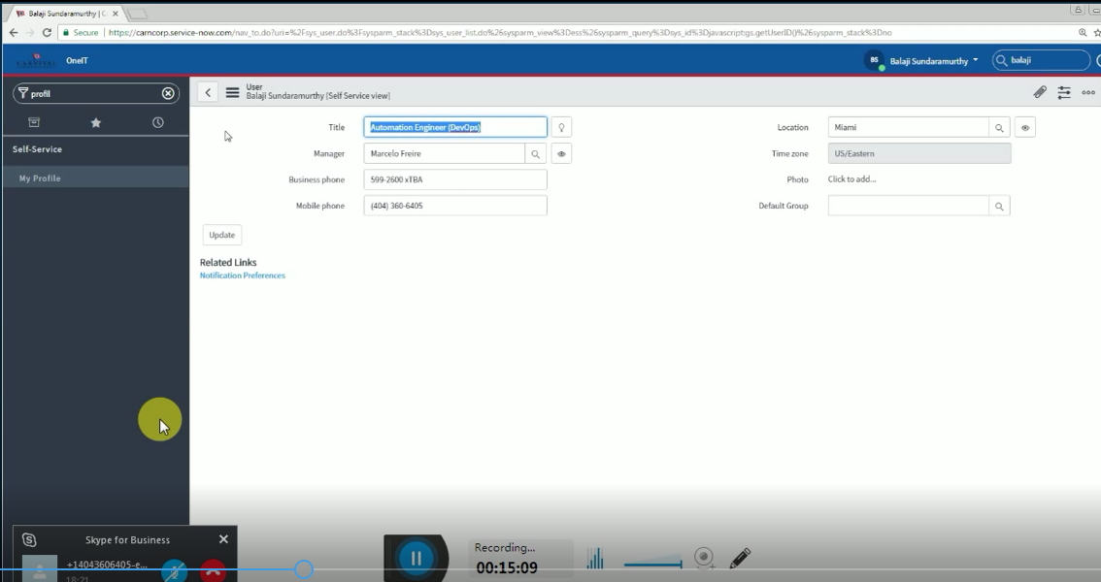

Go to Dashboard -> On call Schedule: you can see the on call person list from all the groups there work timing communication details etc.

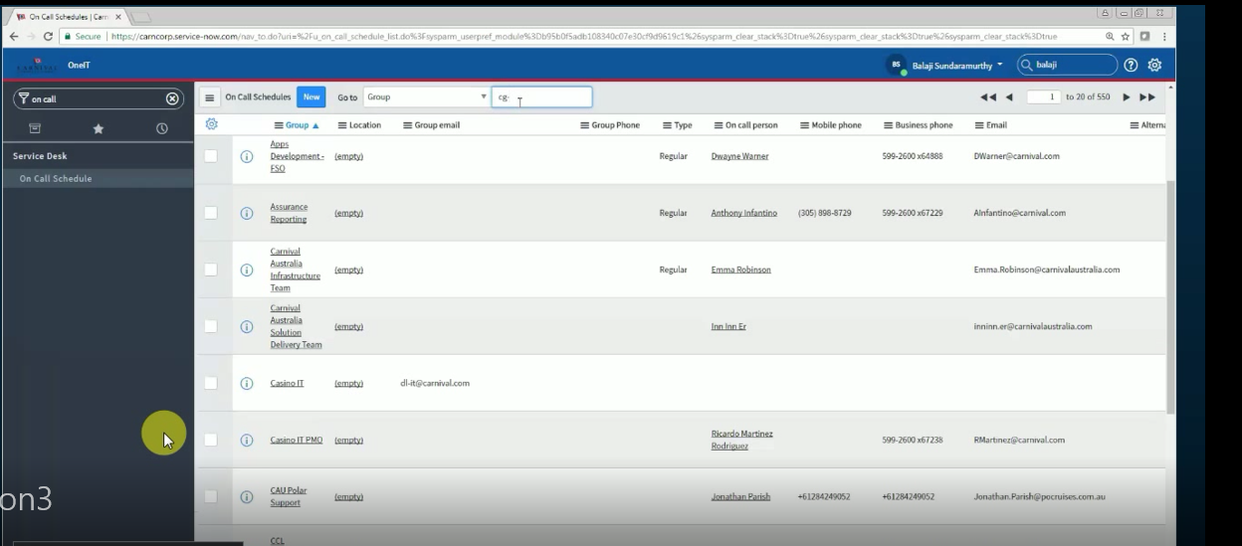

We will create a ticket for various scenario example if we are unable to login to certain servers and we need to restart the server we will create a ticket and assign it to the specific groups based on the scenario and assign a priority to the same once the team solve the ticket issue it will be again reassign to us to review and close the same there is certain duration of time in which we have to solve that ticket or else it will be automatically closed. If the ticket is from the user the user will be notified with the mail that the ticket is resolved and review the same.

To create New ticket Click on Dashboard -> incident-> create

Submit the priority and assignee and problem statement with various other information.

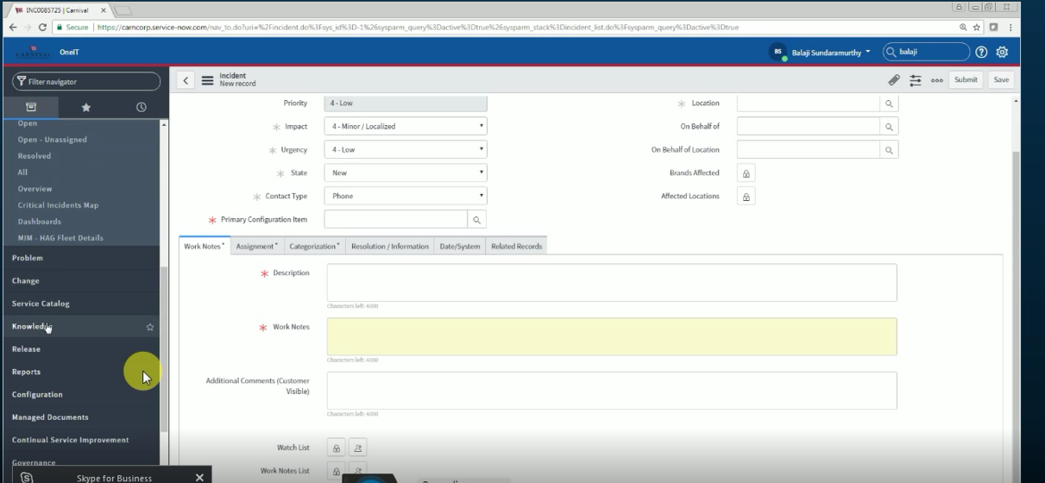

Generating a Change Request :

Dashboard-> Change Request-> create

The Change request which we create a basically of three types we only create the following change request

1. Normal Request: This request is the normal request and created for various pack works or any server upgrations this contains various phases.
2. Expedital Change Request : this request is created only when the high priority ticket is assigned for example (P1 and P2) and we have to assign the ticket ID to this request.

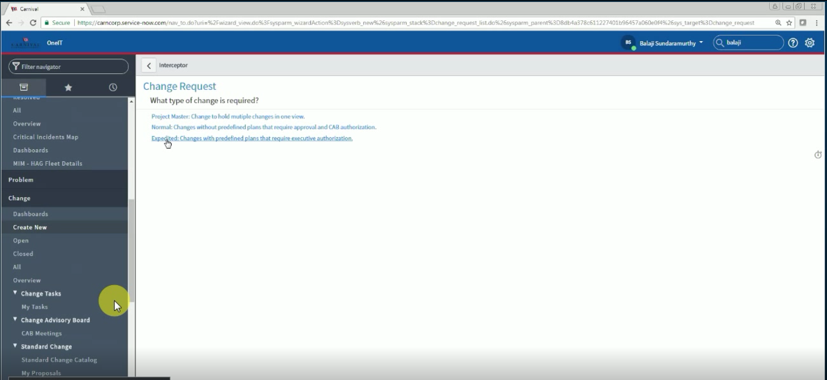

There are various phases while creating a change Request. When we create a ticket it is first in the Draft state then we go to state and change to the next state and click on save changes.

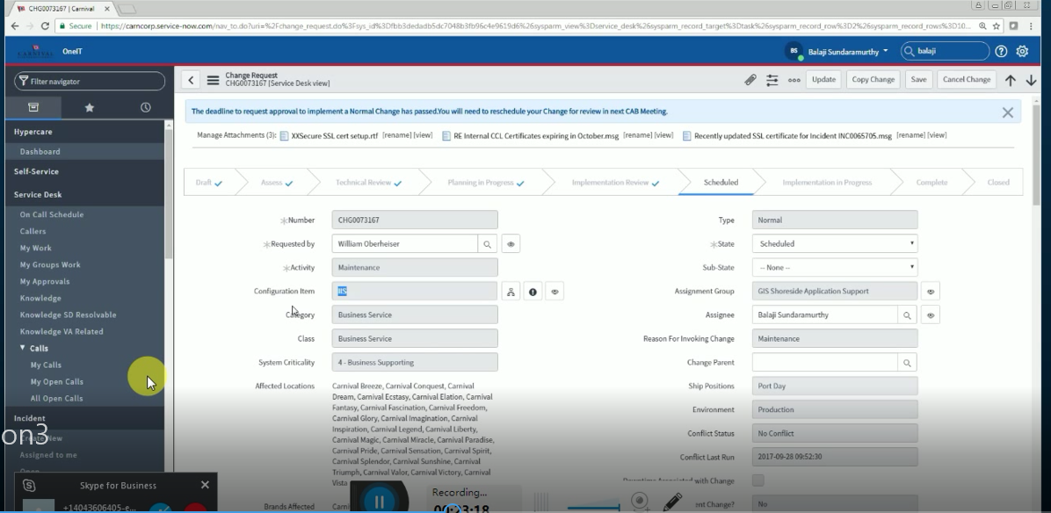

Change Task: Assign it to the respective group we will see the list of groups as follows. Then got to status bar and select the Technical Review state and click on save.

Technical Review: After clicking it will populate the list of approvals from the respective groups for example the change management team etc. we need the approval from all the populated groups.

After getting this change the status from planning in progress and click on save and move to the next stage to implementation review.

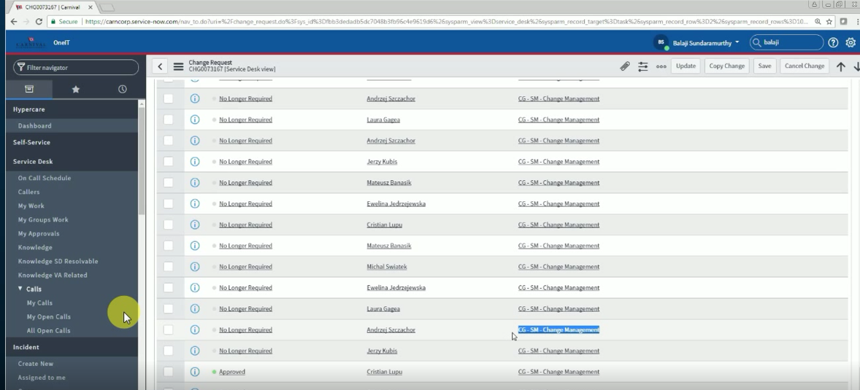

Implementation Review: In this phase again the list will be populated for the necessary approval and after getting the approval we will change the state to CAB review.

CAB Review: we need to schedule the CAB meeting for the specific change request this meeting happen at 1:00 PM on Tuesday and Thursday we have to get the meeting approval 3 hrs before the meeting form the attendees. We have to attend the meeting and answer various question for the change request. One’s the meeting is over we need to change the state schedule.

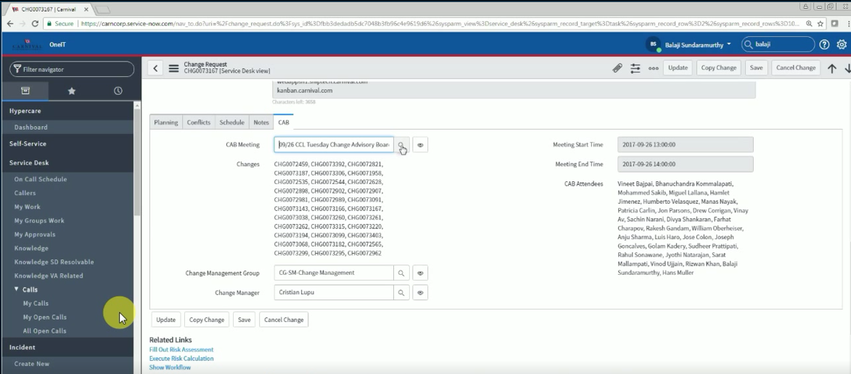

We need to schedule this change request based on this the server will be down at the specific time and date and move the ticket to next stage and save it.

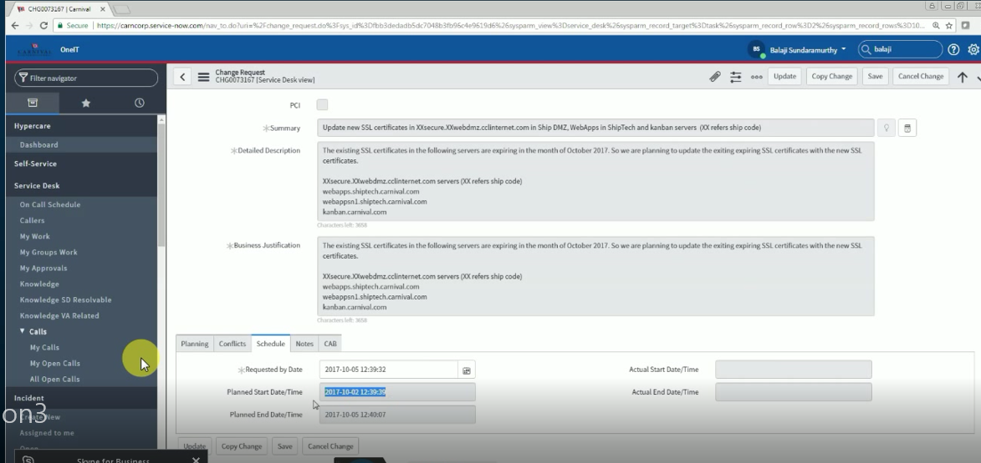

This phase contains the detail planning window it will contain the steps of how to implement and what steps need to be taken if the deployment fails.

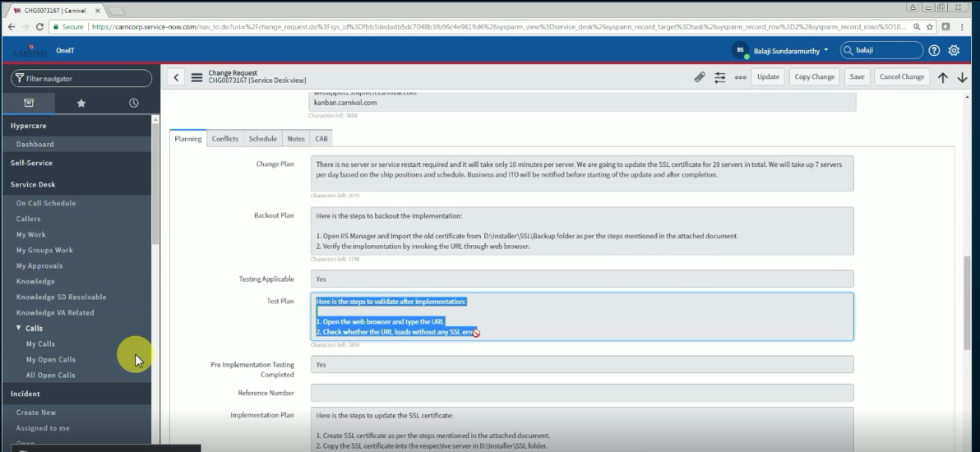

One’s we close the P1 ticket they will automatically create a Problem ticket (Root cause ticket) we need to complete the form and submit it for review.